Society Leader App
G02_19310578

Introduction
The subsystem developed for this coursework is the Society Leader App, a mobile application for the leaders of societies within individual student unions to organise and operate their societies. Its primary role is to facilitate the management of societies by their leaders, and also to manage events promoted to students.

Quality Requirements
Performance
- The system will notify users of society application status within 3 minutes seconds of approval.
- It will be possible to subscribe to a newly approved society within 30 seconds of the society leader activating it
- Society registration data updates will be live within 2.5 seconds of user confirmation
- The system will be able to process 100 society registration data updates per minute
- Society membership approval shall be changed between automatic and manual with no more than 0.5 seconds delay
- Group broadcast messages shall be viewable by students within 2 seconds of posting
- The sending and receiving of individual messages shall take no more than 0.2 seconds
- Submitting a society termination request will halt new subscriptions within 0.5 seconds

Reliability
- Failed actions will be clearly communicated to the user
- Downtime will be restricted to no more than two hours monthly
- Downtime will be scheduled in advance at times which are minimally disruptive to normal operation
Scalability
- The system must allow for horizontal scaling of society application, society approval, and society termination components
Security and Privacy Protection
- The society leader must be logged in before viewing or performing any action relating to the management of the society
- Only the nominated society leader is able to receive the notification of application approval
- A second password entry is required to confirm society activation
- A new society can only be activated by a nominated society leader
- Changing the society registration data shall remove all management privileges from the old society leader upon acceptance by the new society leader
- Upon creation of a new society, membership shall automatically be set to manual approval only
- A second password entry is required to confirm society termination

Use Case Diagram
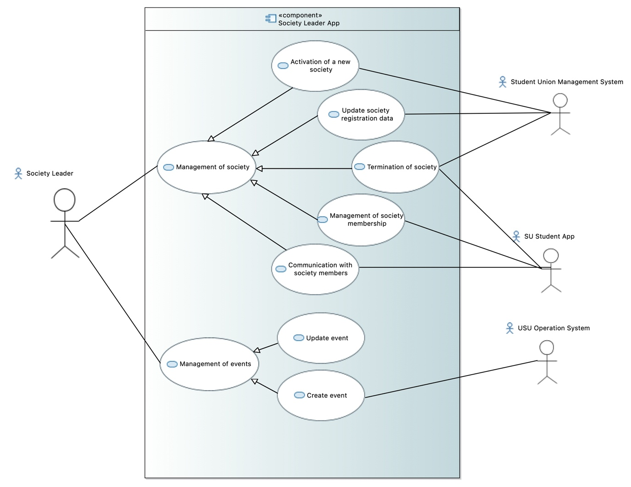

Activity Diagram
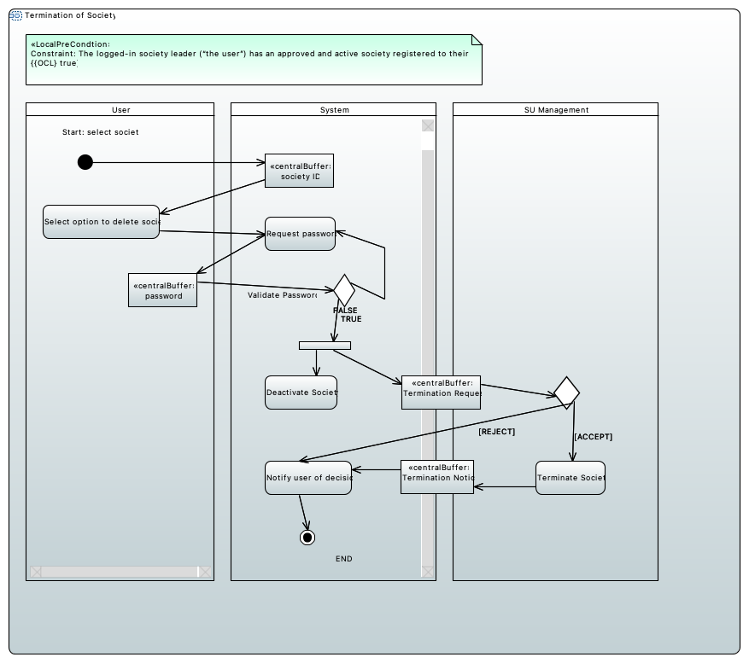
Use Case Scenario: Termination of the society. The system should enable the society leader to submit a request of termination of the society. Once a request of termination the society is submitted, it will become inactive so that no new subscriptions will be allowed. When the society termination request is approved, the society will be removed from the system and all its members will be unsubscribed from the society.
Participants:
Society Leader App (“the system”) – a mobile app to run on mobile phones and on desktop or tablet computers for society leader to organise and operator societies.
USU Student App – mobile app for students to participate in SU activities
Student Union Management System – webapp for officers of each university’s SU to manage and operate their SU
Entry condition:
- The logged-in society leader (“the user”) has an approved and active society registered to their account.
Exit condition:
- The Student Union Management System sends a notification approving or denying the request.
Flow of events:
- The user selects the active society to be modified
- The system displays a menu of options for society management.
- The user chooses the option to delete the society.
- The system displays a confirmation request message and password entry box.
- The user enters their password and confirms the termination request.
- The system deactivates the society, preventing further modification or new subscriptions.
- The system sends a notification to the Student Union Management System requesting termination of the society.
- The union officer approves the request for termination.
- The system receives a notification from the SU Management System that the termination request has been approved.
- The system notifies the user of this decision.
- The Student Union Management System enacts the society deletion process as per FR-UO-3c: Management of Societies, Approval of request of termination of society.

Exceptional conditions and alternative flow of events:
5a. The password is incorrect.
- The system displays the password box again.
- If the password is correct, return to step 6
- After three failed password attempts, the user is locked out and must wait a period of time before trying again.

8b. The union officer rejects the request for termination.
- The system receives a notification from the SU Management System that the termination request has been rejected.
- The system notifies the user of this decision.
- The society remains suspended until either
- another user takes over its leadership and re-activates the society.
or
- The society remains suspended for 18 months and is deleted.

Group Work & Conclusion
I was present from the beginning of the group work. I was more active in earlier weeks and tried to arrange regular meetings, when this fell through I became less engaged but continued going to meetings as much as I was able with my health issues and stayed active on the groupchat. I struggled to meet deadlines consistently but tried to maintain open communication about this.
Unfortunately I was not able to complete the software architectural design and detailed designs due to poor time management and difficulties with Papyrus. However I feel I have a good grasp on structural and behavioural models, and will continue to study architectural design creation and practice with the software to improve my abilities in this area.

